**IP Quiz (HTML, JavaScript, CSS) Total Marks: [8+6+4+6+6= 30]**

**Roll No. ________________________________**

**Q1. a.** Draw a picture of how the following HTML and CSS code will look when the browser renders it onscreen. Indicateany non-default font with a squiggled underline like this. You can indicate a background coloring by shading lightlyor by drawing repeated diagonal lines like this. No manual line breaks have been inserted into the text.  **[6]**

**HTML**

|  |  |
| --- | --- |
| **<html><head>**   |  | | --- | | **Q1. b. Write code to attach CSS file given below (named Q1.CSS) to this HTML page. [2]**  **<link rel="stylesheet" type="text/css" href=" Q1.CSS "></link>** |   **</head><body>**  <h1>h1</h1>  <p id="one">You only think I guessed wrong! That's what's so funny! I  switched glasses when your back was turned!</p>  <p class="one">You fell victim to one of the  classic blunders!</p>  <p class="one" id="two">Never get involved in<br />a land  war<a href="http://www.asia.com/">in</a>asia.</p>  <h2 class="three">Ha ha ha!</h2>  **</body></html>** |

**CSS**

|  |  |
| --- | --- |
| **h1** {  float:right;  font-size: 10em; }  **h2** {  border: 2px solid black;  clear: both;  font-family: monospace; } | **.one** { background-color: yellow; }  **h2** { width: 50%; }  **#two** {  text-align: right;  border: 3px dashed black; }  **.three** {  border-left: none;  border-right: none; } |

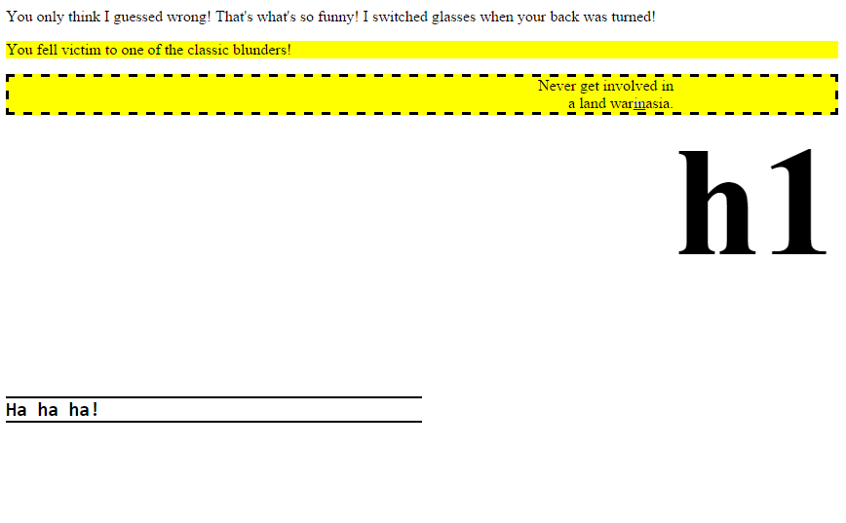

**Q2.** Which **property/attribute** will be used to change given **From** parts of html page (column 1) to **To** parts (column 1). **[6]**

e.g. for the first scenario, which attribute will be used such that text appearing aligning to top of image (From) is aligned to top of image (To)? You’ve to make changes in given Code (column 3).

|  |  |  |  |
| --- | --- | --- | --- |
| **From** | **To** | | Code (From) |
|  |  | | **<html>**  **<body>**  **<img id="img1" src="a1.jpg" height="100px" width="100px" />**  **<span>hello this is some text </span>**  **</body>**  **</html>** |
| **Answer: (Re Write only those tag(s) below that need to change )**  **<img id="img1" style="float:left;" src="a1.jpg" height="100px" width="100px" />** | | | |
|  |  | | **<html>**  **<body>**  **<table>**  **<tr>**  **<td>A1</td><td>A2</td><td>A3</td>**  **</tr>**  **<tr>**  **<td>B1</td><td>B2</td><td>B3</td>**  **</tr>**  **<tr>**  **<td>C1</td><td>C2</td><td>C3</td>**  **</tr>**  **</table>**  **</body>**  **</html>** |
| **Answer: (Re Write only those tag(s) below that need to change )**  **<table border="1" cellpadding="10px">** | | | |
| 1. What is a correct result of interpreting all the following JavaScript lines?  var x = "The axis at 23.5"  var y = 0;  findTheX(x);  function findTheX(the_text)  {y=the_text.indexOf("x");}  **A. y is -1;**  **B. y is 0;**  **C. y is 5;**  **D. y is 6;** | | To create a drop down list for a form, which syntax would you use?  1. **The general <SELECT> and <DROPDOWM> tags.** 2. **The general <SELECT> and <OPTION> tags.** 3. **The general <OPTION> and <TEXT> tags.** 4. **The general <SELECT> and <ITEM> tags.** | |
| 3. What is the correct HTML for making a text area?   1. **<input type="textarea" />** 2. **<input type="textbox" />** 3. **<textarea>** | | 1. Which set of tags looks like this? ·Dogs  ·Cats  ·Birds 2. **<ul></ul>** 3. **<ol></ol>** 4. **<u></u>** 5. **<dl></dl>** | |

**Q4**. What will be the output for following? **[6]**

|  |  |
| --- | --- |
| **<html><body>**  **<script>**  **function foo()**  **{**  return 2;  **}**  **function test() {**  document.write(a);  document.write(foo());  var a = 1;    **}**  test();  **</script>**  **</body></html>** | **Output:**  undefined2 |
| **<html>**  **<body>**  **<script>**  **function test()**  **{**  a = "abc";  document.write(a);  a=10;  a=a+2;  document.write(a);  **}**  test();  **</script>**  **</body>**  **</html>** | **Output:**  abc12 |

**Q5.** Write two java script functions: [6]

1. **AddtoArray(var item)** function to add items in a blank array (make a global array for this).
2. **getMostFrequent()** function to find the most frequent item of the global array you created.

Note: You just have to write javascript function. HTML code is not needed.

|  |
| --- |
| var x = 0;  var arr1 = Array();  **function AddtoArray(var item)**  {  arr1.push(item);  }  //var arr1=[3, 'a', 'a', 'a', 2, 3, 'a', 3, 'a', 2, 4, 9, 3];  **function getMostFrequent()**  {  var mf = 1;  var m = 0;  var item;  for (var i=0; i<arr1.length; i++)  {  for (var j=i; j<arr1.length; j++)  {  if (arr1[i] == arr1[j])  m++;  if (mf<m)  {  mf=m;  item = arr1[i];  }  }  m=0;  }  alert(item+" ( " +mf +" times ) ") ;  } |